Virtual Box
Download virtual box from https://www.virtualbox.org/wiki/Downloads, for your particular platform.
Important. In order to access Virtual Box from different PC’s and from home and college PC’s, Install into your own private (Citrix) partition. Contact IT support if you have questions about access to Citrix. Virtual Box might already be installed on your machine / citrix partition.

Virtual Machine
The following instructions were executed on a Windows 7 environment with a 2.3 Ghz Pentium Dual Core CPU. 3 GB installed memory.
A – Download Ubuntu appliance from
https://www.dropbox.com/s/g7wj63hpqjdy4nf/Ubuntu%2012.04.ova
B - Import Ubuntu 12.04 Appliance
Start VirtualBox, and choose “import Alliance”.
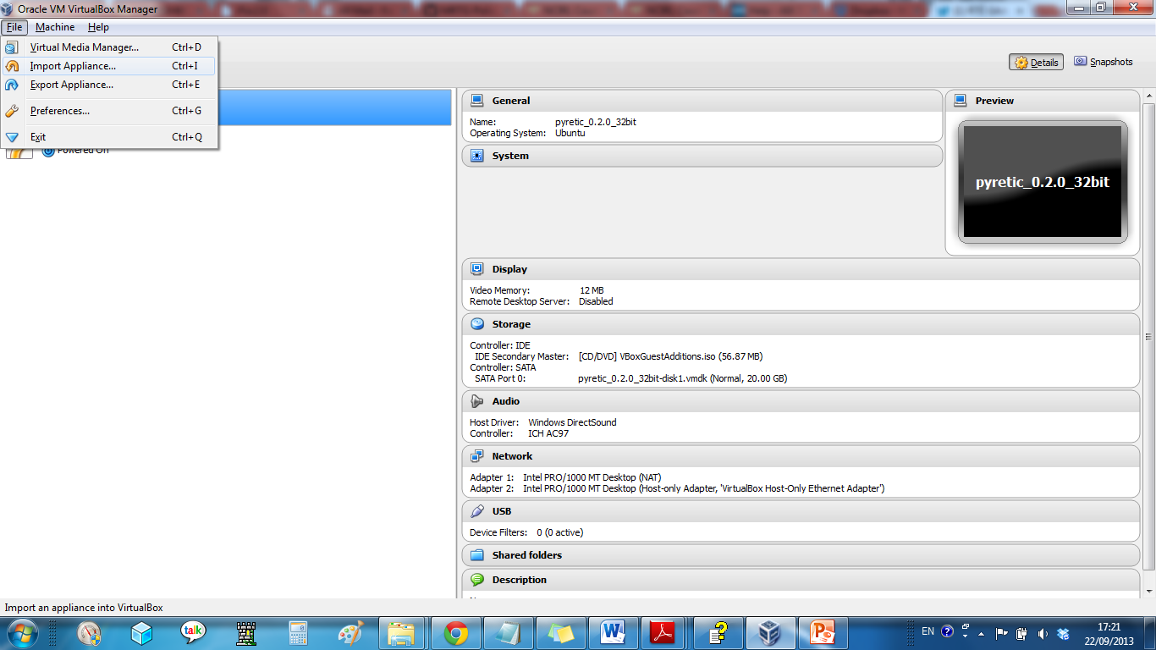
Select the .ova file that was downloaded from DropBox.
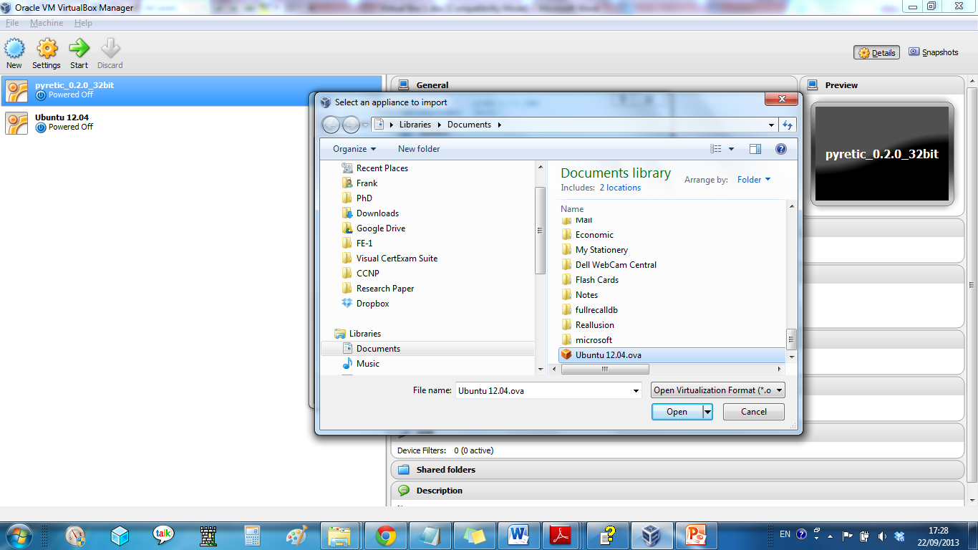
Start Appliance by selecting the Ubuntu 12.04 appliance on the left handside, and pressing Start.
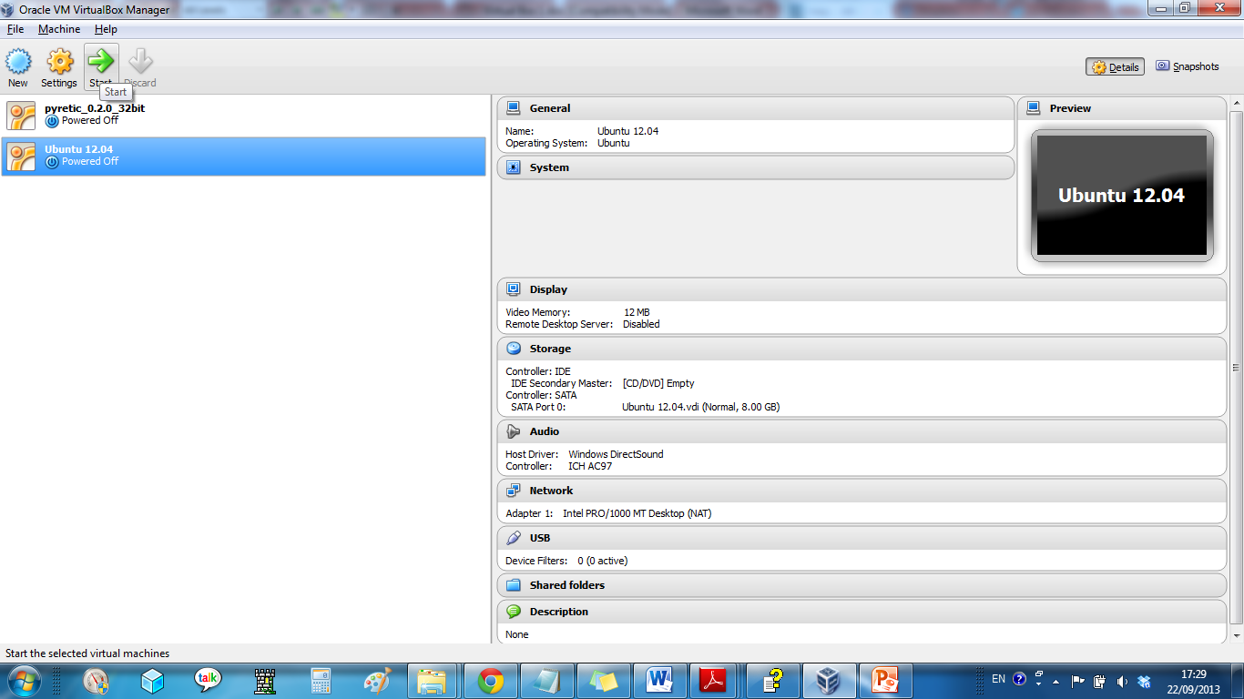
The log-in username and password is testuser and password respectively. You may log in through the console, which you initially receive or through SSH (port 2222 on localhost / 127.0.0.1).
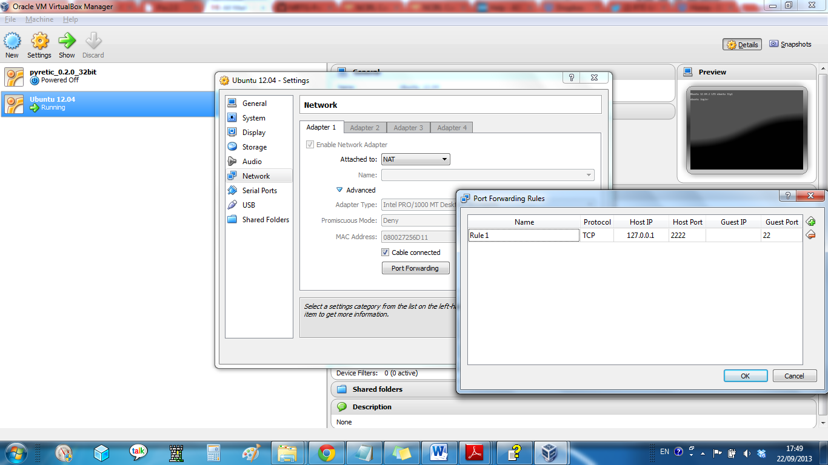
If you run more than one version of this appliance, then the local host port of the additional machines needs to be made unique i.e. 2223 or 2224 etc.
C - Snapshot
At any time that the virtual machine is running it is possible to take a snapshot of the machine. This preserves all changes to virtual machine up to that point. There can be any number of snapshots. When the virtual machine is being started, the base image can be started or any of the snapshots can be started. Snapshots can be deleted, as required.
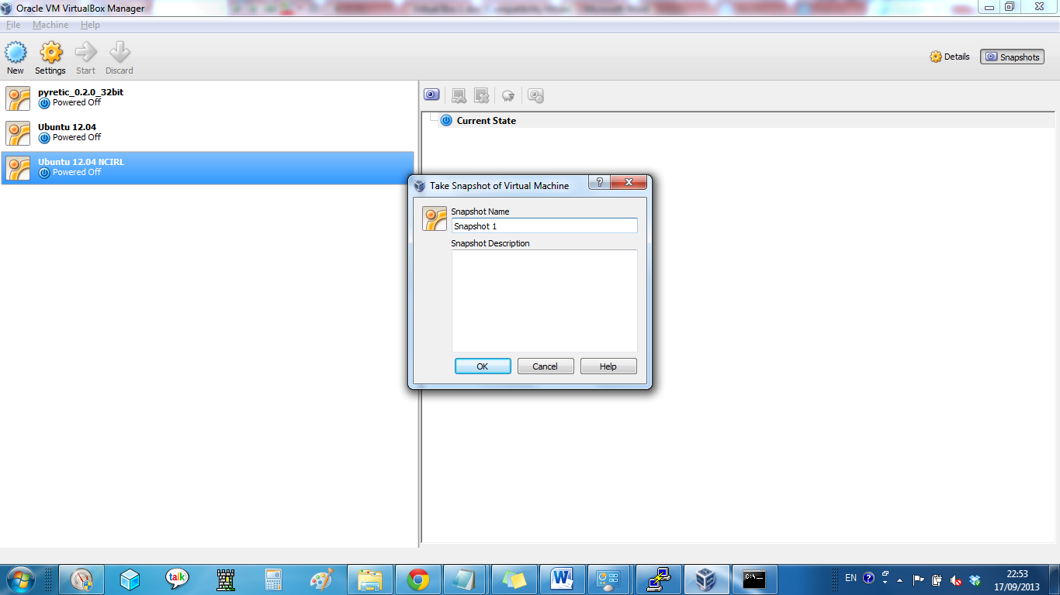
D – Cloning
Cloning allows a complete replica of a virtual machine to be created and started separately from the original virtual machine. Within reason there is no limit (accepted resource limitations) to the number of clones created and started. It should be possible to created an array of virtual machines that then can communicate with each other over a (virtual network).
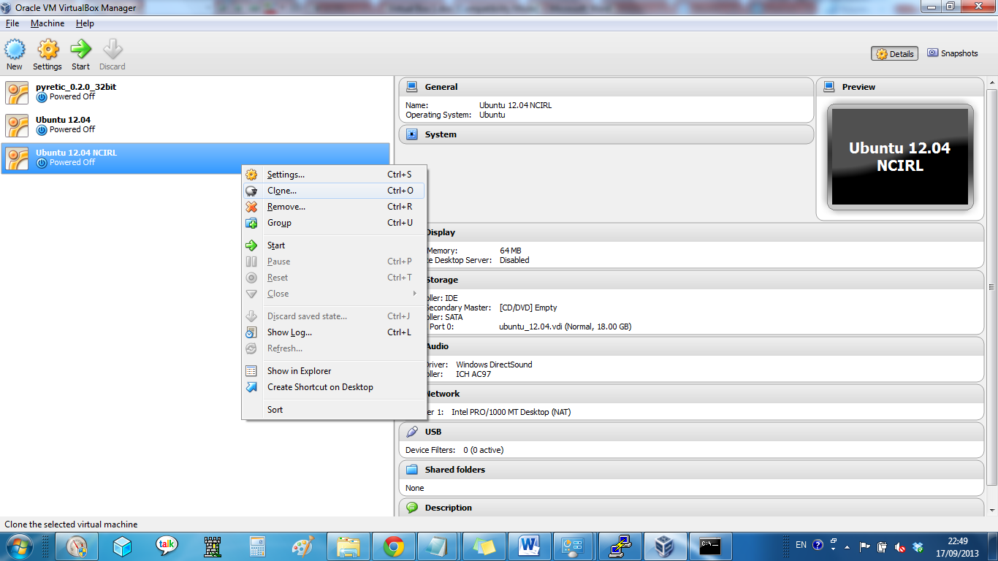
E – SSH client
Install Putty client from http://www.chiark.greenend.org.uk/~sgtatham/putty/download.html. For Windows there is an installer (putty-0.63-installer.exe).
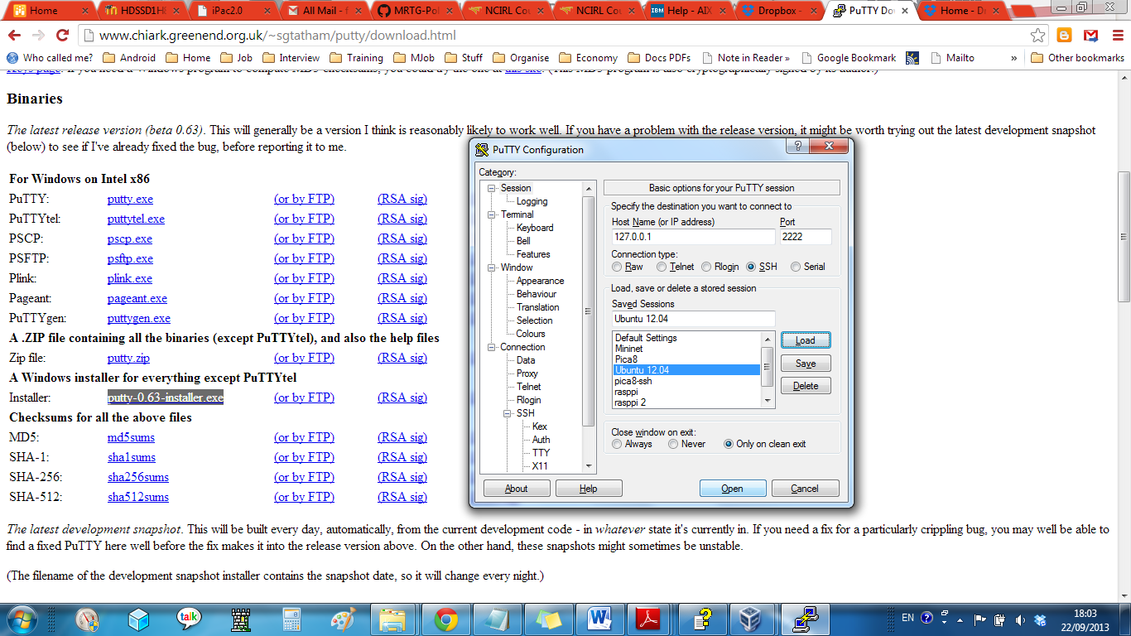
For IP address enter 127.0.0.1 and Port 2222,
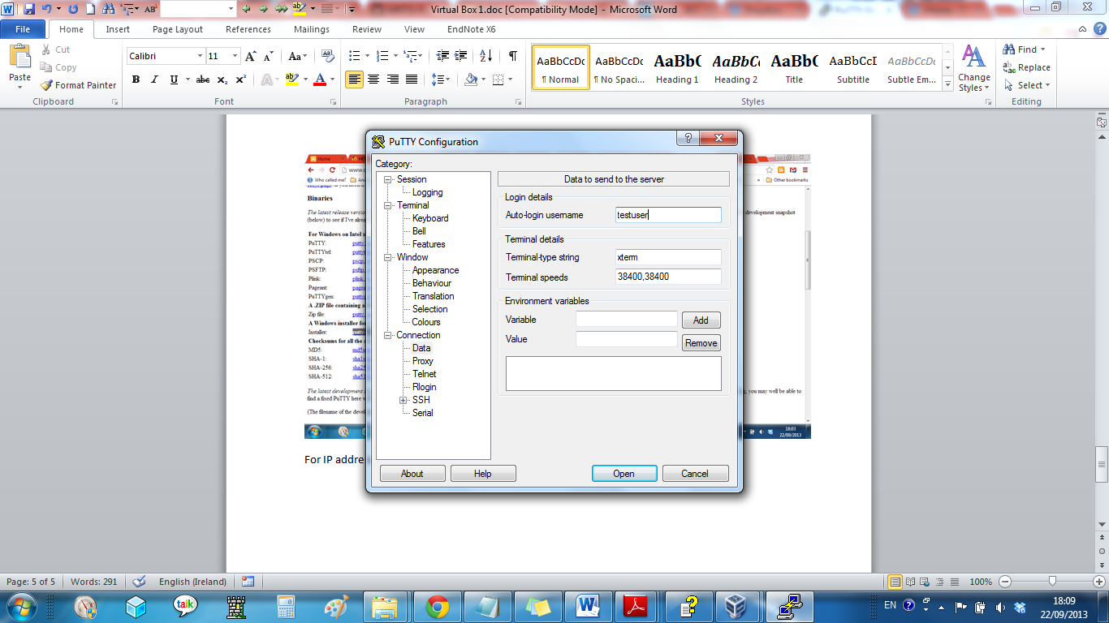
Add auto-login username of testuser.
Save profile as Ubuntu 12.04.
Some application might need an X-windows interface. Install Xming from http://sourceforge.net/projects/xming/. This runs silently in the background on the local desktop. The Putty SSH client will forward the X11 windows to the locak desktop.

